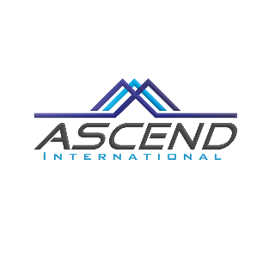
Ascend International
5448 Apex Peakway #249
Apex, North Carolina 27502 (USA)
Passages’ Application Summer 2022
Thank you for your interest in Passages, Ascend International’s Cross Cultural Leadership Development program for collegians and young adults. Passages is a leadership development program built heavily on interactions with USA program hosts, families and leaders. Passages’ is not an entertainment program (although you certainly will have fun). Please do not join the program if you simply want to come to the USA to: shop, hang out with friends or be entertained. The expectation of Ascend and the volunteers who host you is that you are coming to learn and develop.
Please download this word document and type in your answers in English. Save the document and send it to the email address specified at the bottom of the application. Please answer each question to the best of your ability. Take as much space as you require. AI seeks to give all applicants a decision within two weeks of their application. If you apply and do not receive a decision within two weeks, please email AI at the email listed at the bottom of this application. Applications will be accepted until each Passages Company Program is filled.

Name in Native Language (Pinyin): Date:
English name (if applicable):
Your present school, university or employer: City You Presently Live:
Gender (Male or Female?): Age:
Have you completed an undergraduate degree? If so, what was your field of study?
If you are in graduate school, what is your present field of study?
Email:
Mobile:
WeChat ID:

For which internship are you applying?
If you are interested in more than one, please rank them in order of personal preference:

Please provide a personal introduction to yourself (take as much space as you require):

What are your areas of strength?
What are areas of your life that need developing?

How did you hear about this program?

Why do you want to be chosen for this particular program?

Why should Ascend choose you to participate in the program?

Please list any paid or volunteer experience you have had along with your personal responsibilities in the activity.

If you are selected for the Passages’ program, what do you most hope to gain from your experience?

Please tell us, briefly, what you hope to be doing 10 years from now.
Have you been vaccinated against Covid 19?
If you have been vaccinated, which vaccines have you received?

Please answer “yes” or “no” to the following statements:
l. If accepted to the program I may be living with a host family. I will submit to the rules of their home and seek to be a good house guest.
2. I agree to comply with the rules given to me by my leaders. Disrespecting leaders or those assigned to watch over your care may lead to immediate dismissal from the program. I understand if I willfully disregard instruction from program leaders/host families etc. I may be asked to leave the program, immediately, at my own expense.
2. I understand that I may be the first Chinese person my company or host family has ever hosted. I understand China is not the USA and I will do my best to observe behaviors that communicate respect in my host culture (USA). I will do my best to be courteous, thoughtful and professional in my interactions with my hosts.
3. I understand, although the internship is usually approximately 40 hours/week, the program has other activities in the evenings and on weekends. I agree to participate in all activities (evenings, weekends) and will not make other plans that may interfere with my involvement.

Thank you for your interest in coming to the U.S.A and participating in Passages. AI leadership and volunteers look forward to hosting young adults like you each year. If selected, we promise you will gain a rich experience that will help you be “ready for tomorrow.”
Please submit your application for Passages to: garmstrong@ascend-international.com
If you any questions, please direct them to Guy at the email listed above, or contact him by phone in the U.S. (919.332.9004) or by WeChat: guyarmstrong

